FINAL REPORT
Team ID: LTVIP2026TMIDS80392
Title: Heart Disease Analysis

1.INTRODUCTION:

1.1 Project Overview

Heart disease remains one of the leading causes of mortality worldwide. Its prevalence continues to rise due to lifestyle changes, unhealthy dietary habits, physical inactivity, and increasing stress levels. Despite advancements in medical science, prevention and early detection remain critical in reducing severe outcomes and improving patient survival rates. Analysing large-scale healthcare data—including patient demographics, medical history, lifestyle choices, and clinical indicators—requires advanced data visualization tools to extract meaningful insights.

1.2 Purpose
The purpose of this project is to analyse heart disease data using Tableau to identify major risk factors affecting cardiovascular health. The project aims to transform raw healthcare data into meaningful and interactive visualizations. It focuses on understanding how age, BMI, lifestyle habits, and medical conditions influence heart disease occurrence. By uncovering patterns and correlations, the analysis supports data-driven decision-making. Ultimately, the project promotes awareness and preventive strategies to reduce heart disease risk.

2. IDEATION PHASE
2.1 Problem Statement
Problem Statement (PS) | I am (Customer) | I’m trying to | But | Because | Which makes me feel
PS – 1 | A doctor or healthcare professional handling heart disease patients. | Analyze  patient health data quickly to identify heart disease risks early. | Manual analysis of multiple medical parameters takes time and may lead to error | Large volumes of patient data make it difficult to identify important risk factors accurately. | Overwhelmed and concerned about missing early warning signs in patients.
PS – 2 | A patient  concerned about my heart health. | Understand  my risk level and take preventive action early | Medical  reports are complex and difficult for me to interpret. | There is no  simple system that clearly explains heart disease risk in an easy way. | Confused and anxious  about my health condition.
2.2 Empathy Map Canvas
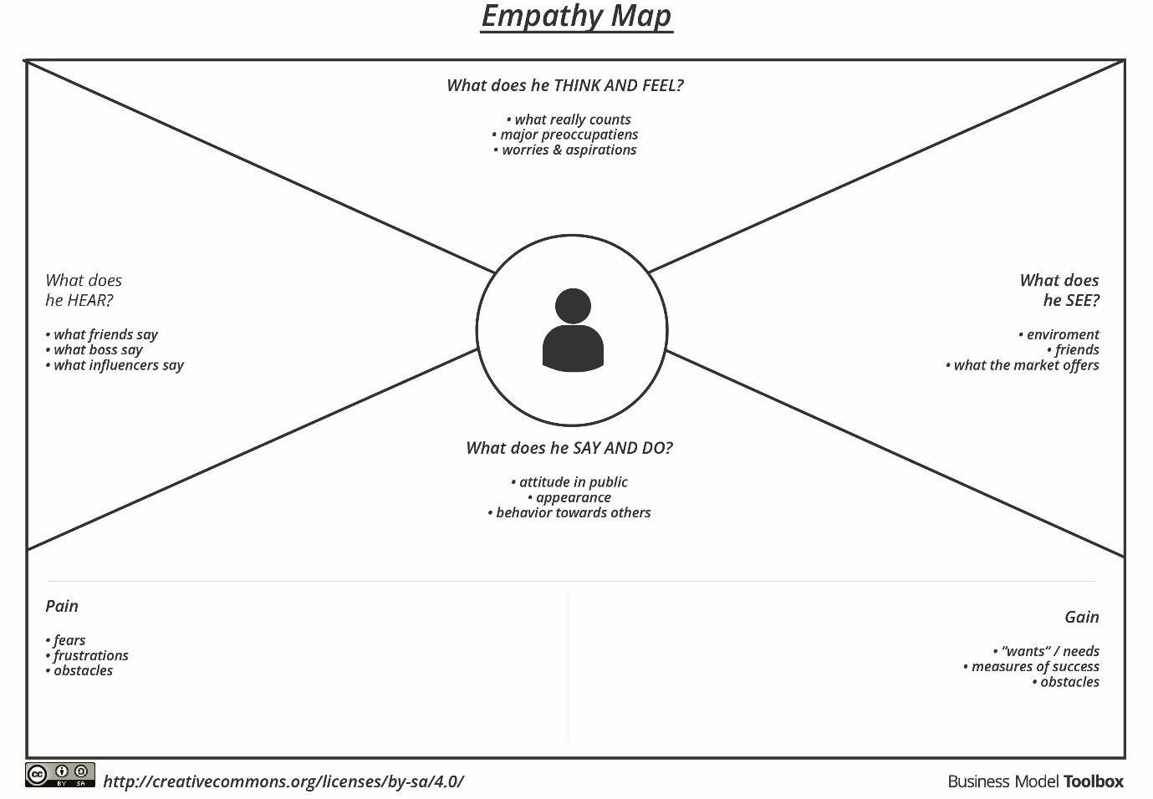

2.3 Brainstorming
S. No | Ideas Generated | Category
1 | Visualize heart disease distribution across different age groups | Age-based Analysis
2 | Compare heart disease occurrence between male and female patients | Gender Comparison
3 | Analyze BMI distribution and its relationship with heart disease | Health Risk Assessment
4 | Study the impact of smoking and alcohol consumption on heart disease | Lifestyle Analysis
5 | Examine the relationship between diabetes and heart disease | Medical Condition Analysis
6 | Analyze stroke history and its influence on heart disease occurrence | Risk Factor Evaluation
7 | Compare heart disease rates among physically active vs inactive individuals | Behavioral Analysis
8 | Highlight states with highest and lowest per capita electricity usage | Health Status Comparison
9 | Show changes in urban vs rural electricity consumption | Visualization Enhancements
10 | Integrate external datasets like population or weather for deeper insights | Insight & Decision Support

3. REQUIREMENT ANALYSIS
3.1 Customer Journey map
Customer Journey Stages:
Stage 1: Problem Awareness
User Realization:
- Heart disease cases are rising due to lifestyle factors.
- Lack of early detection tools.
- Difficulty in comparing patient risk profiles.
Pain Points:
- Raw health data is hard to interpret.
- No centralized dashboard for risk analysis.
- Limited visibility into regional and demographic trends.

Stage 2: Data Exploration
User Actions:
- Access Tableau dashboard
- Filter by age, gender, region, and lifestyle indicators.
- Compare patient groups and risk factors.

System Response:
- Displays interactive graphs and heatmaps
- Highlights top risk contributors (e.g., smoking, high BMI)
- Enables regional and demographic comparisons.

Stage 3: Insight Discovery
User Discovers:
- Middle-aged patients with high cholesterol and smoking habits are at greatest risk
- Urban regions show higher prevalence due to sedentary lifestyle
- Lockdown periods reduced physical activity, increasing risk.
- Certain demographics show consistent upward trends in heart disease.

Stage 4: Decision Making
User Decisions:
- Launched targeted awareness campaigns for high-risk groups
- Promote lifestyle changes like physical activity and healthy diets
- Allocate resources for early screening in vulnerable regions
- Develop preventive health policies and incentives

Customer Journey Visualization Flow
- Problem + Data Access + Filtering → Visualization → Insights → Strategic Decision
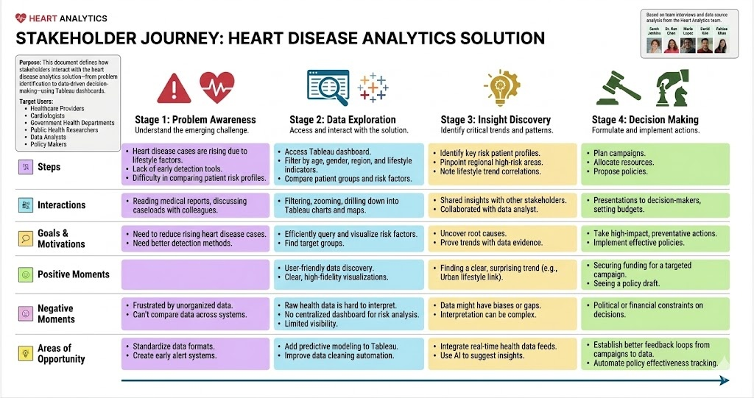

3.2 Solution Requirement
Functional Requirements:
FR No. | Functional Requirement (Epic) | Sub Requirement (Story / Sub-Task)
FR-1 | User Registration | Registration through Form, Registration through Gmail, Registration through LinkedIn
FR-2 | User Confirmation | Confirmation via Email, Confirmation via OTP
FR-3 | User Login & Authentication | Login using Email & Password, Forgot Password, Session Management
FR-4 | Data Upload & Management | Upload patient health data, Validate input data, Store data securely
FR-5 | Data Preprocessing | Handle missing values, Feature scaling, Data normalization

Non-functional Requirements:
Following are the non-functional requirements of the proposed solution.
FR  No. | Non-Functional Requirement | Description
NFR-1 | Usability | The system should be easy to use with a simple and intuitive interface for users and doctors.
NFR-2 | Security | User data and medical information must be securely stored with authentication and authorization mechanisms.
NFR-3 | Reliability | The system should provide accurate and consistent prediction results with minimal failures.
NFR-4 | Performance | The system should process data and display predictions quickly with minimal response time.
NFR-5 | Availability | The application should be accessible whenever required with minimal downtime.
NFR-6 | Scalability | The system should support increased users and larger datasets without performance degradation.

3.3 Data Flow Diagram
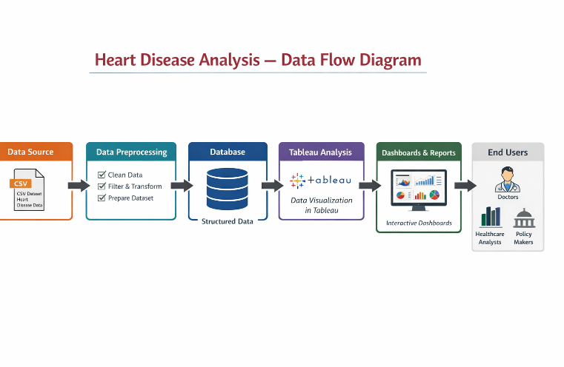
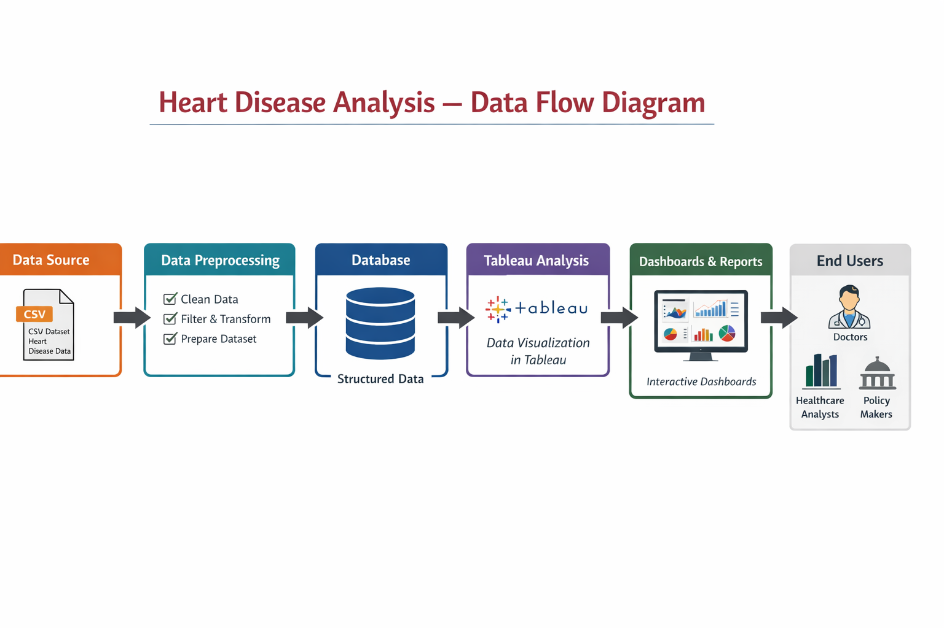3.4 Technology Stack

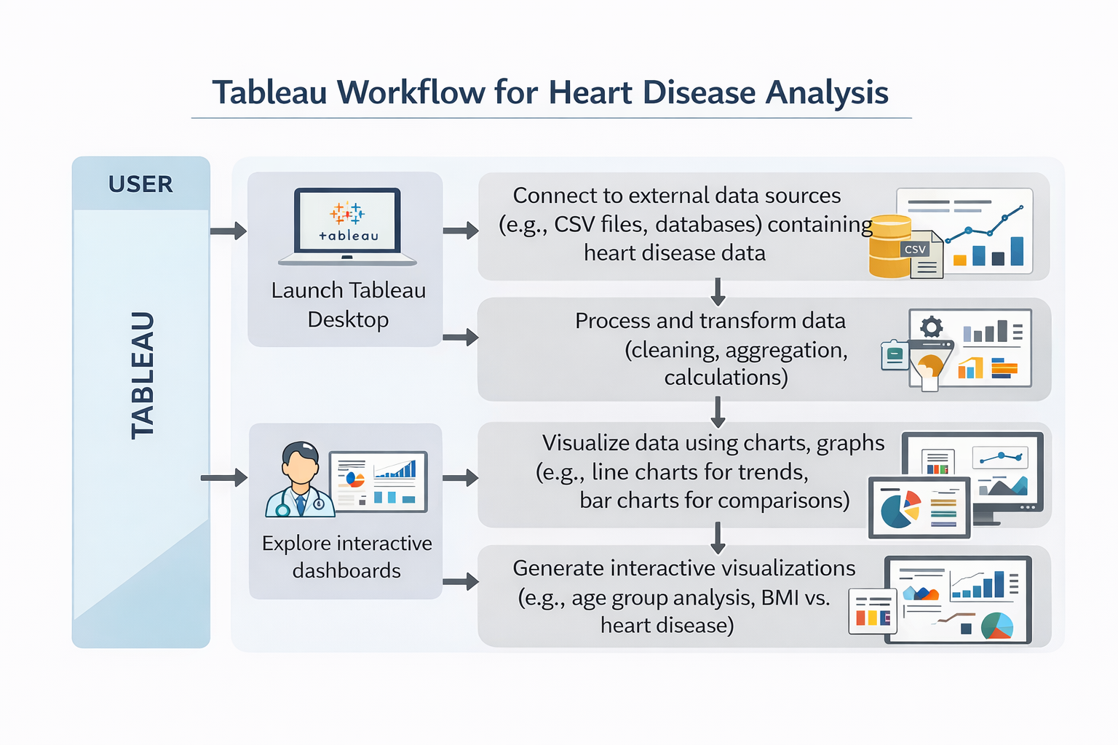
4. PROJECT DESIGN
4.1 Problem Solution Fit
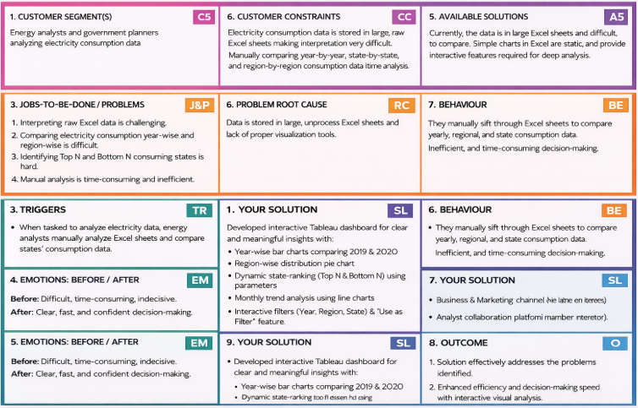
4.2 Proposed Solution

S .No. | Parameter | Description
 | Problem Statement (Problem to be solved) | Electricity consumption data is stored in large Excel sheets, making it difficult to interpret, compare year-wise and region-wise trends, and identify high and low consuming states. Manual analysis is time-consuming and inefficient for decision-making.
 | Idea / Solution description | Develop an interactive Tableau dashboard that visualizes electricity consumption data using bar charts, line charts, and pie charts. The dashboard includes year-wise comparison, region-wise distribution, Top N & Bottom N state analysis, monthly trend visualization, and interactive filters (Year, Region, State).
 | Novelty / Uniqueness | The solution integrates dynamic filtering, parameter-based Top N and Bottom N analysis, and cross-sheet interaction in a single dashboard. It transforms static Excel data into an interactive, user-friendly analytical system.
 | Social Impact / Customer Satisfaction | The dashboard helps energy planners and analysts make faster and more accurate decisions. It improves transparency in electricity consumption patterns and supports better energy planning and resource allocation.
 | Business Model (Revenue Model) | The solution can be adopted by government agencies, electricity boards, and energy companies. It can be implemented as a data analytics service or integrated into energy management systems for performance monitoring.
 | Scalability of the Solution | The dashboard can be expanded to include additional years, renewable energy data, predictive analytics, and real-time data integration. It can also be adapted for other sectors such as water consumption or fuel usage analysis. predictive analytics, and real-time data integration. It can also be adapted for other sectors such as water consumption or fuel usage analysis.

4.3 Solution Architecture
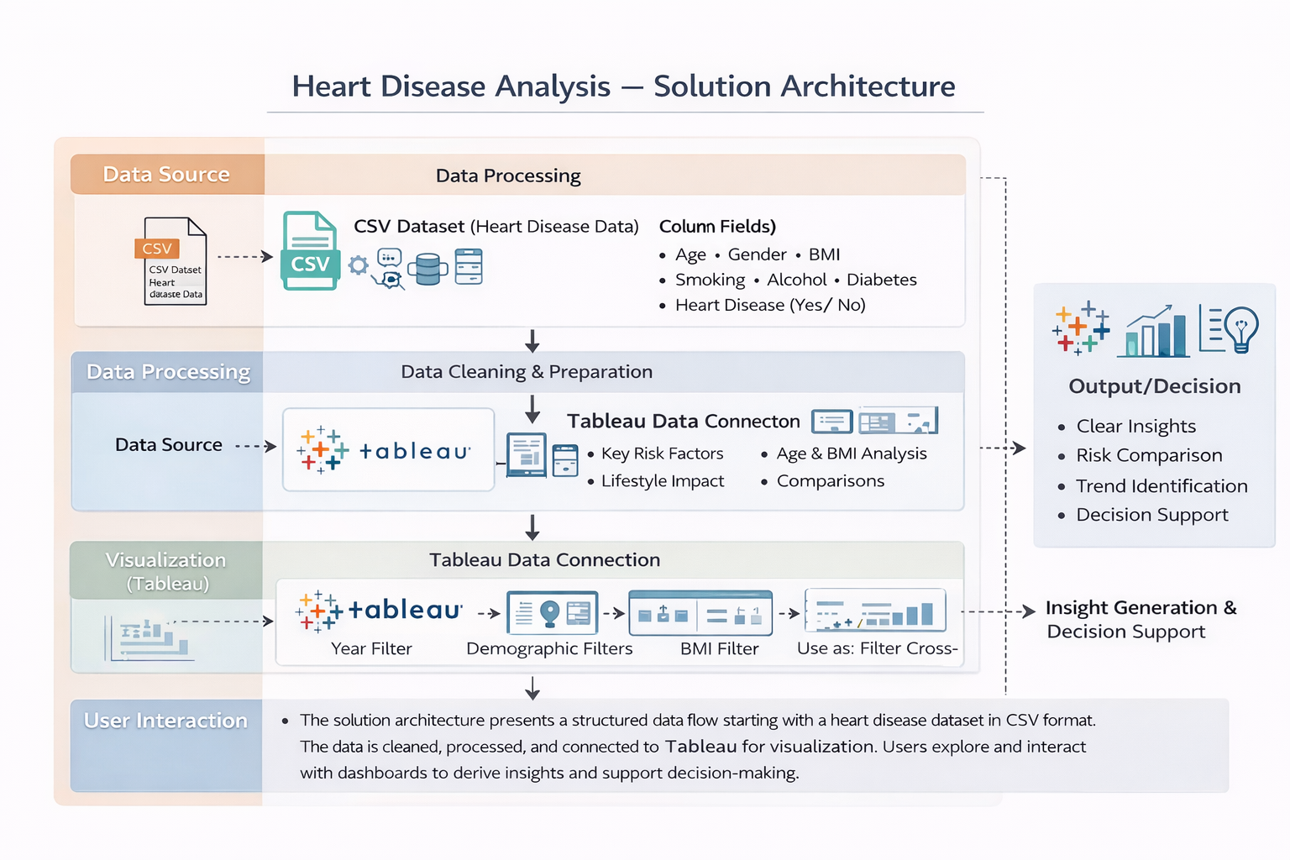

5. PROJECT PLANNING & SCHEDULING
5.1 Project Planning
Product Backlog, Sprint Schedule, and Estimation

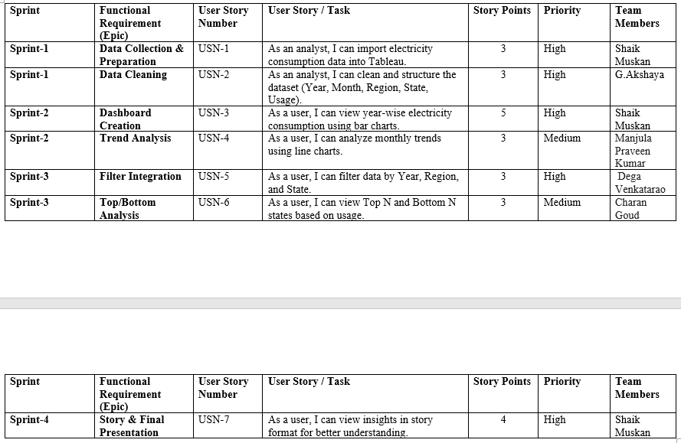

Project Tracker, Velocity & Burndown Chart
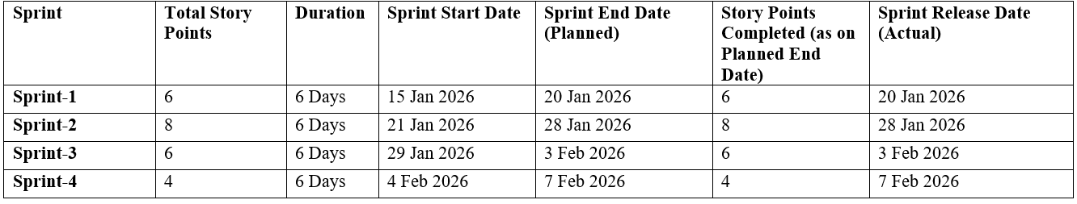
Velocity:
Total Story Points Completed = 24 Number of Sprints = 4
Average Velocity = 24 ÷ 4 = 6 Story Points per Sprint
If sprint duration = 6 days
Velocity per day = 6 ÷ 6 = 1 Story Point per Day
Burndown Chart:
A Burndown Chart was used to track the remaining work against time during each sprint. The chart shows the ideal work completion line and the actual progress line. The project maintained steady progress, and story points were completed within the planned sprint duration, indicating effective sprint planning and execution.

6. FUNCTIONAL AND PERFORMANCE TESTING
6.1 Performance Testing
S.No. | Parameter | Screenshot / Values
 | Data Rendered | The dashboard successfully renders heart disease data without noticeable delay. The dataset includes Age Category, Gender, BMI, Smoking, Alcohol, Diabetes, Stroke, and Heart Disease fields. All visualizations load within acceptable response time.
 | Data Preprocessing | Data was cleaned before visualization. Categorical fields were verified, BMI bins were created for histogram analysis, and null values were checked and handled appropriately.
3. | Utilization of Filters | Interactive filters such as Age Category, Gender, BMI (bin), and Health Conditions were implemented. “Use as Filter” functionality enables cross-sheet interaction. Dashboards update dynamically when filters are applied.
4. | Calculation fields Used | Calculated fields such as COUNT of patients, BMI bin grouping, percentage calculation, and category-based aggregation were implemented to enhance analysis.
5. | Dashboard design | Number of Visualizations / Graphs – 10 (Bar Charts, Histogram, Comparative Analysis, Percentage Distribution, KPI Overview). Layout is structured, clean, and responsive.
6 | Story Design | Story points are arranged logically to explain heart disease trends, risk factors, comparisons, and insights step by step. The storytelling approach improves understanding of the analysis.

7. RESULTS
7.1 Output Screenshots
Dashboard Screenshots:

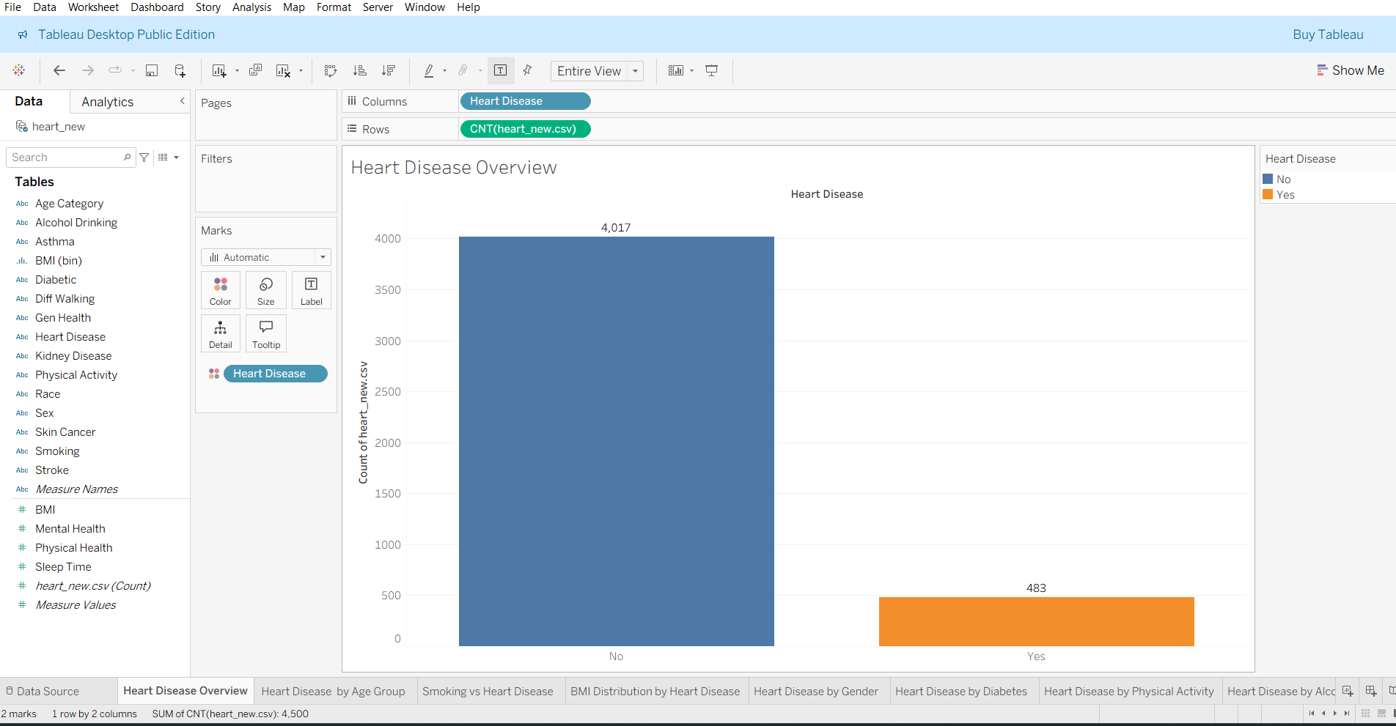
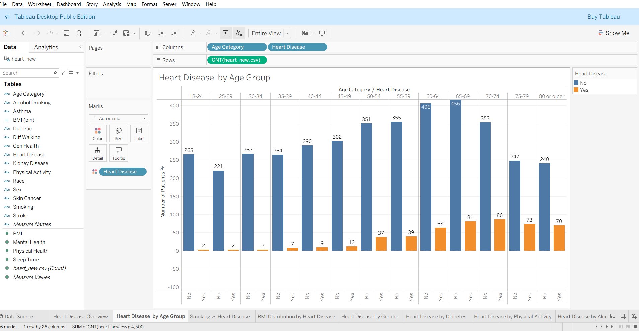

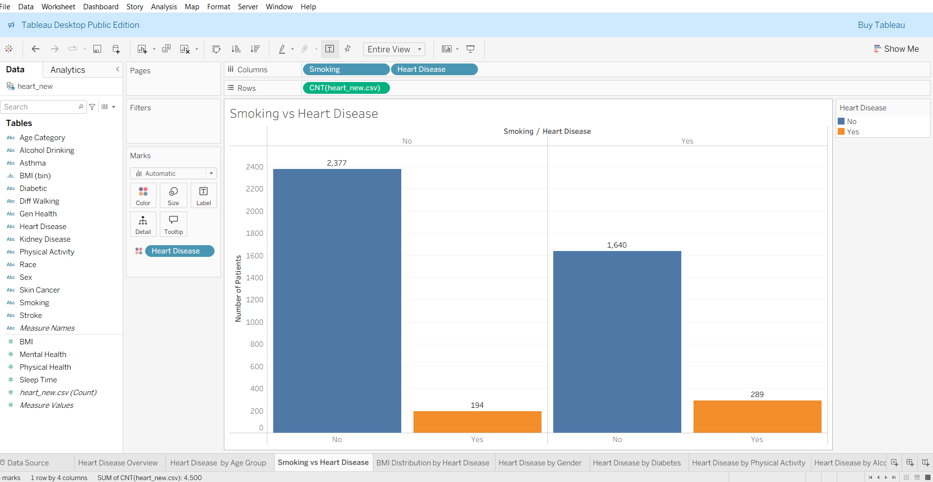
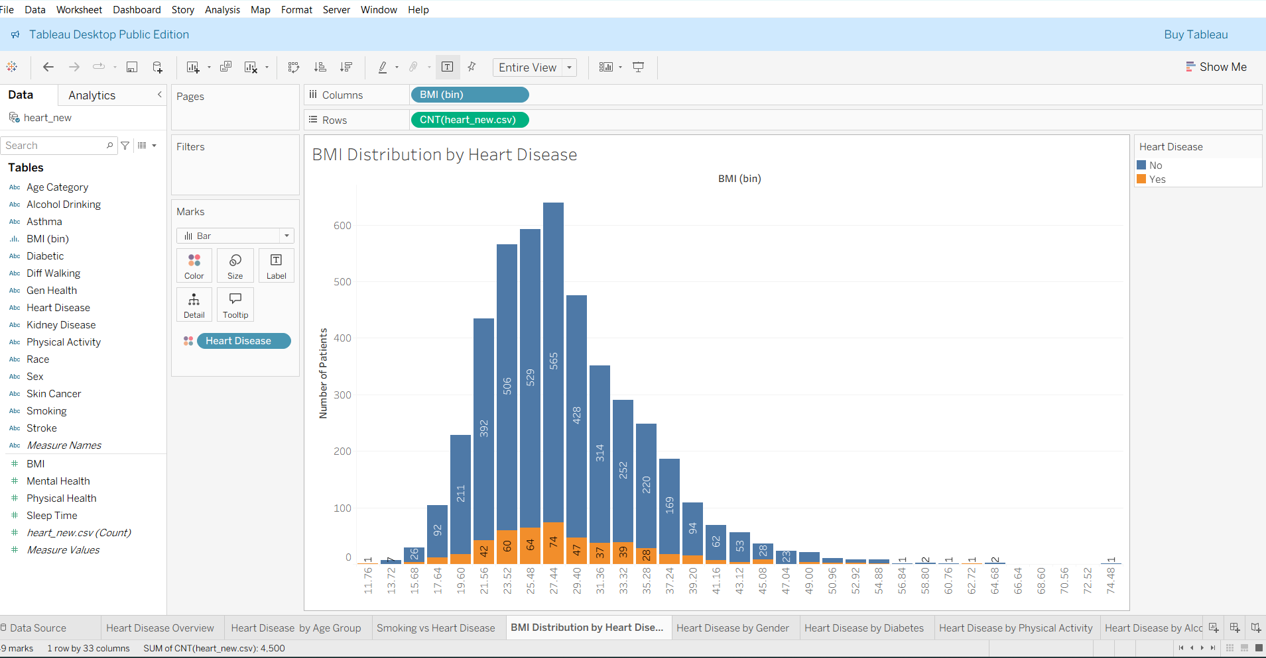
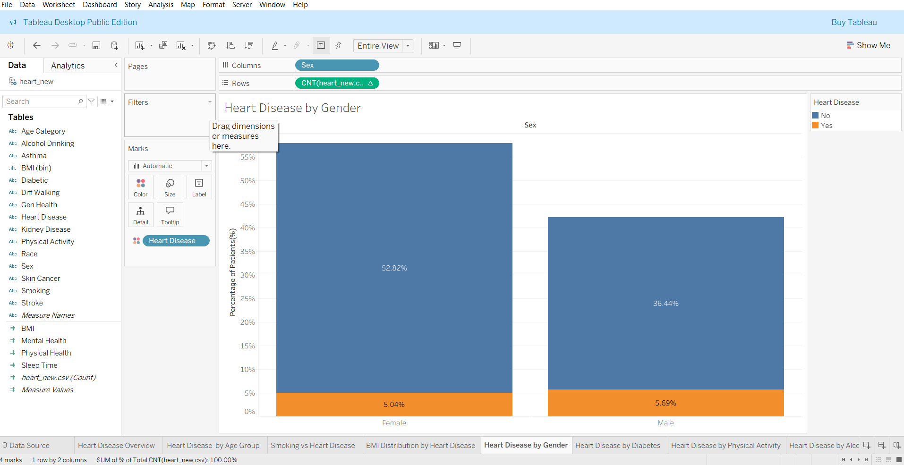
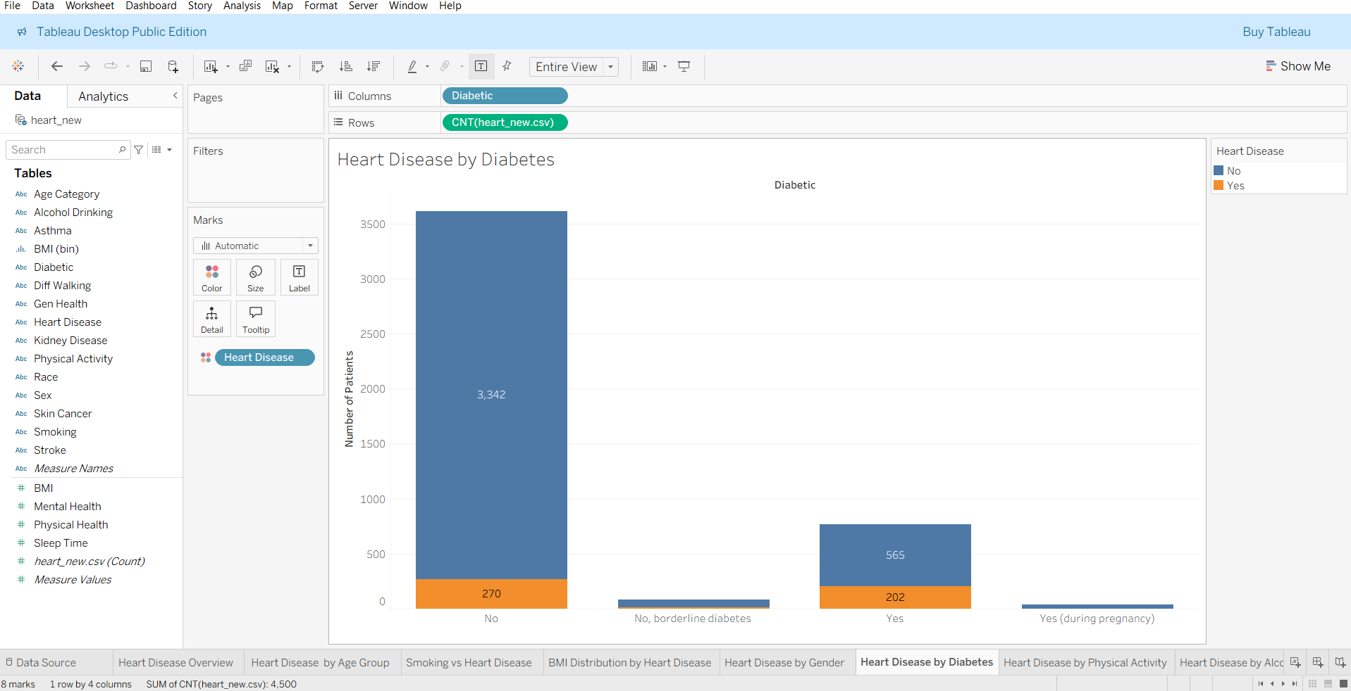
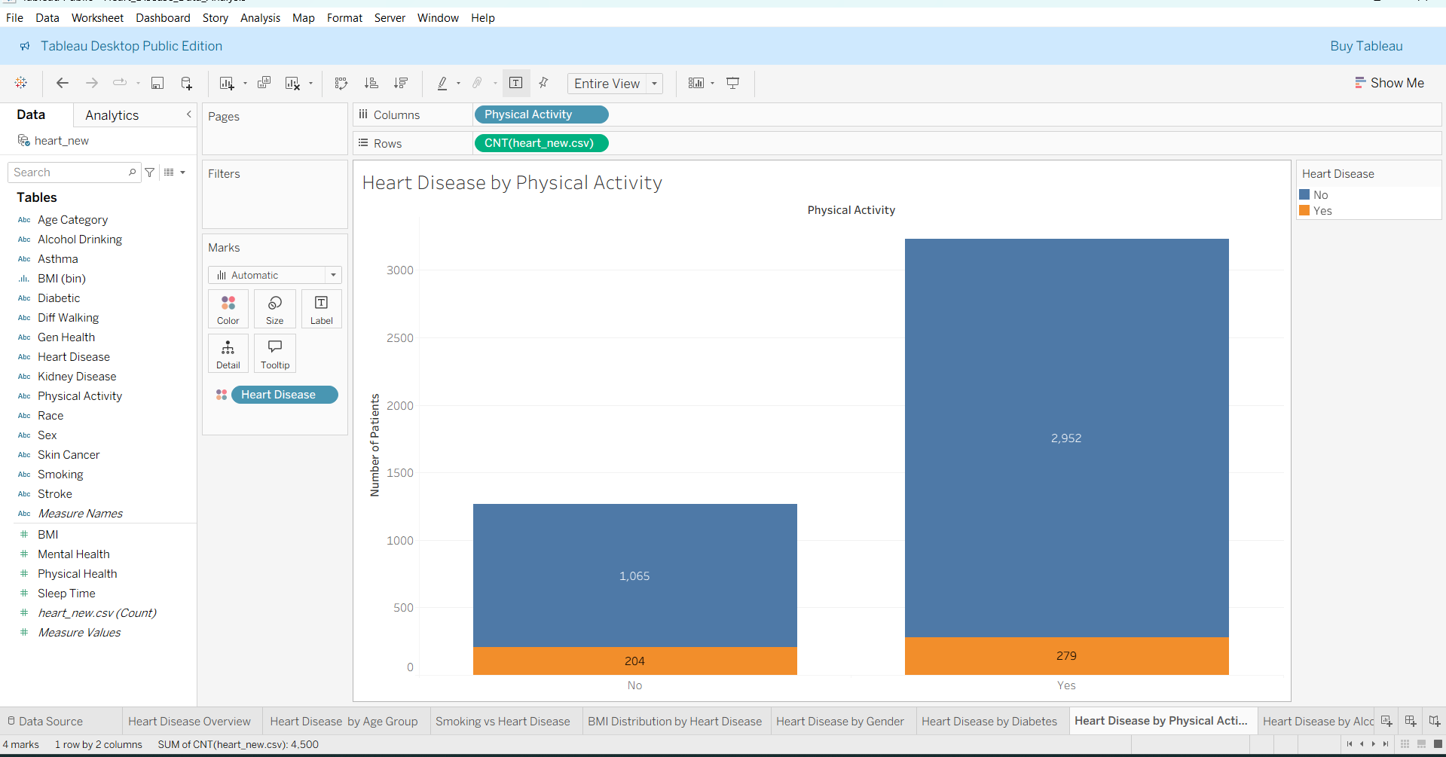
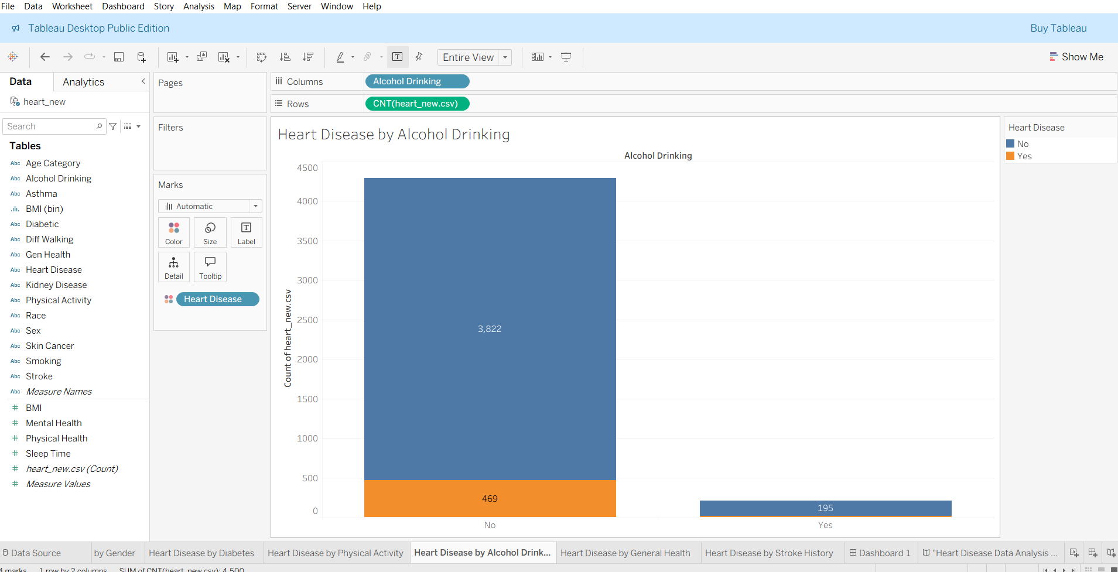
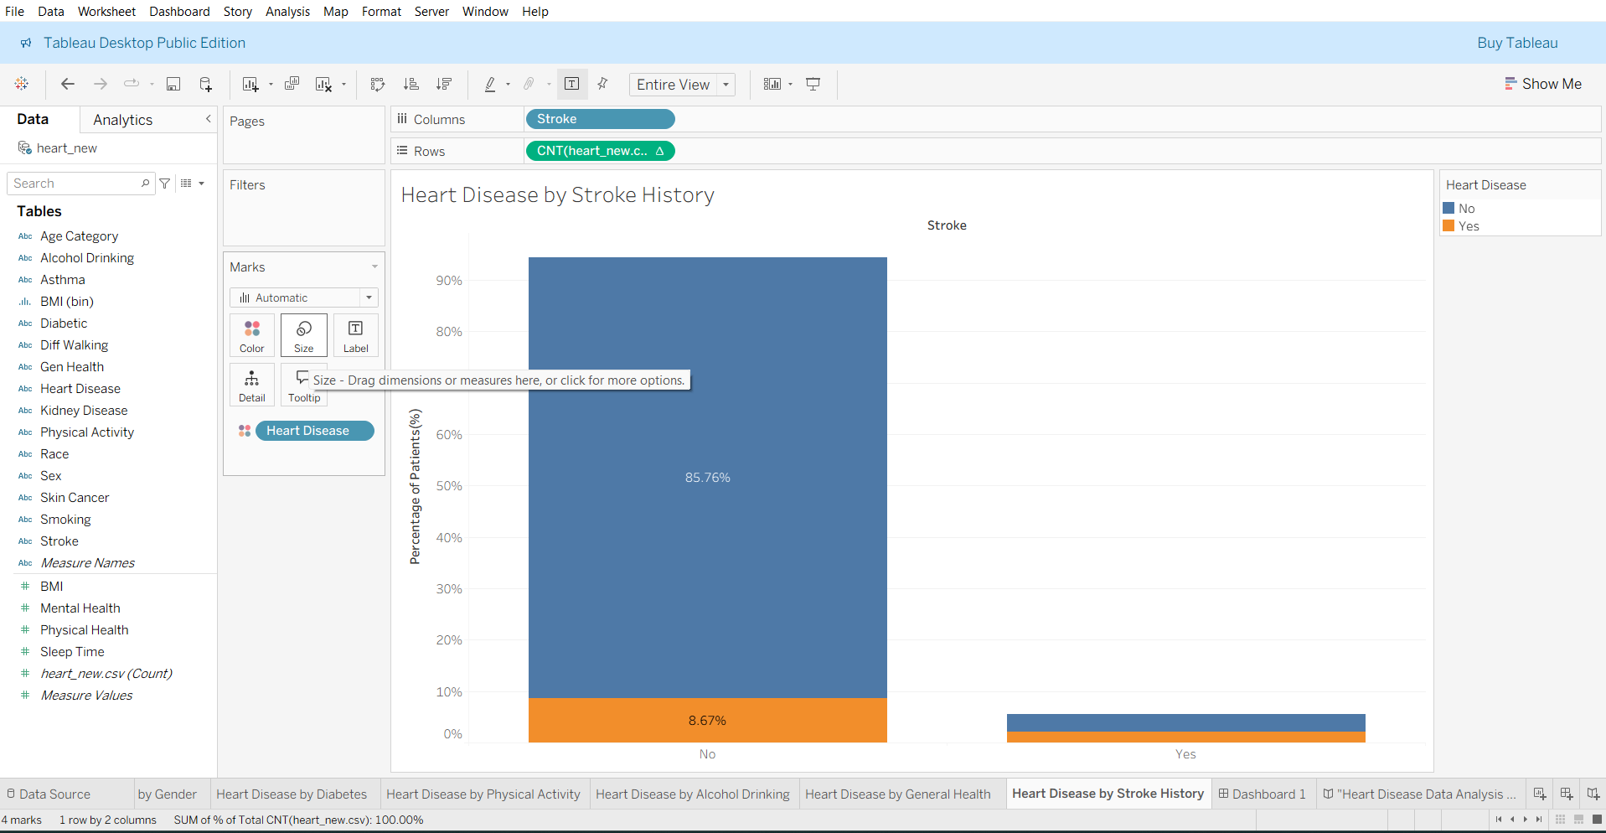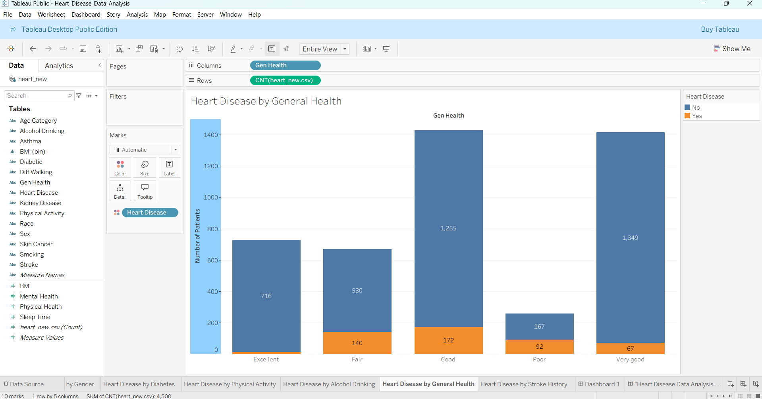
Dash Board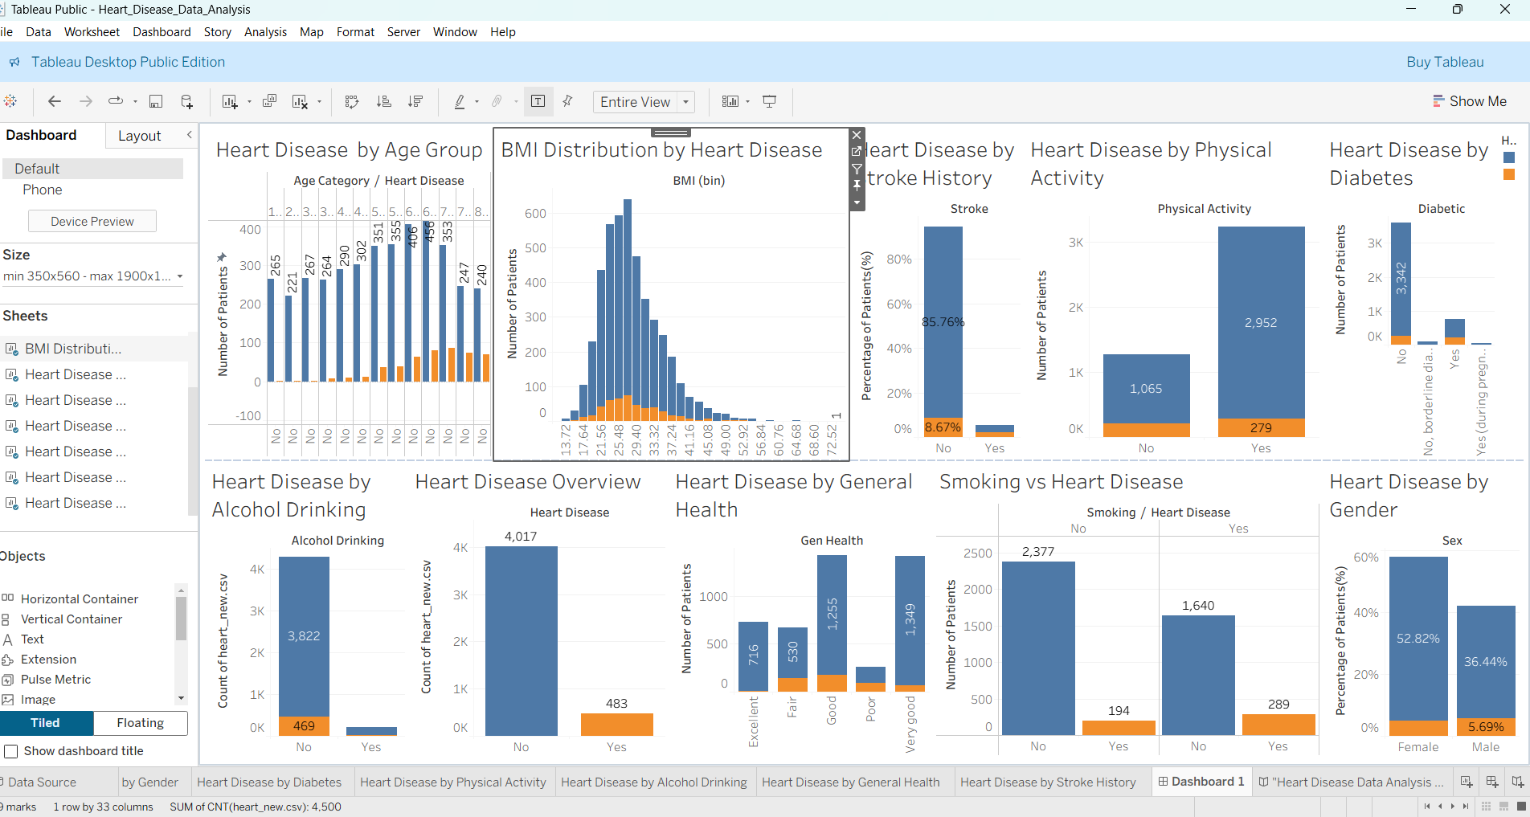

Story:
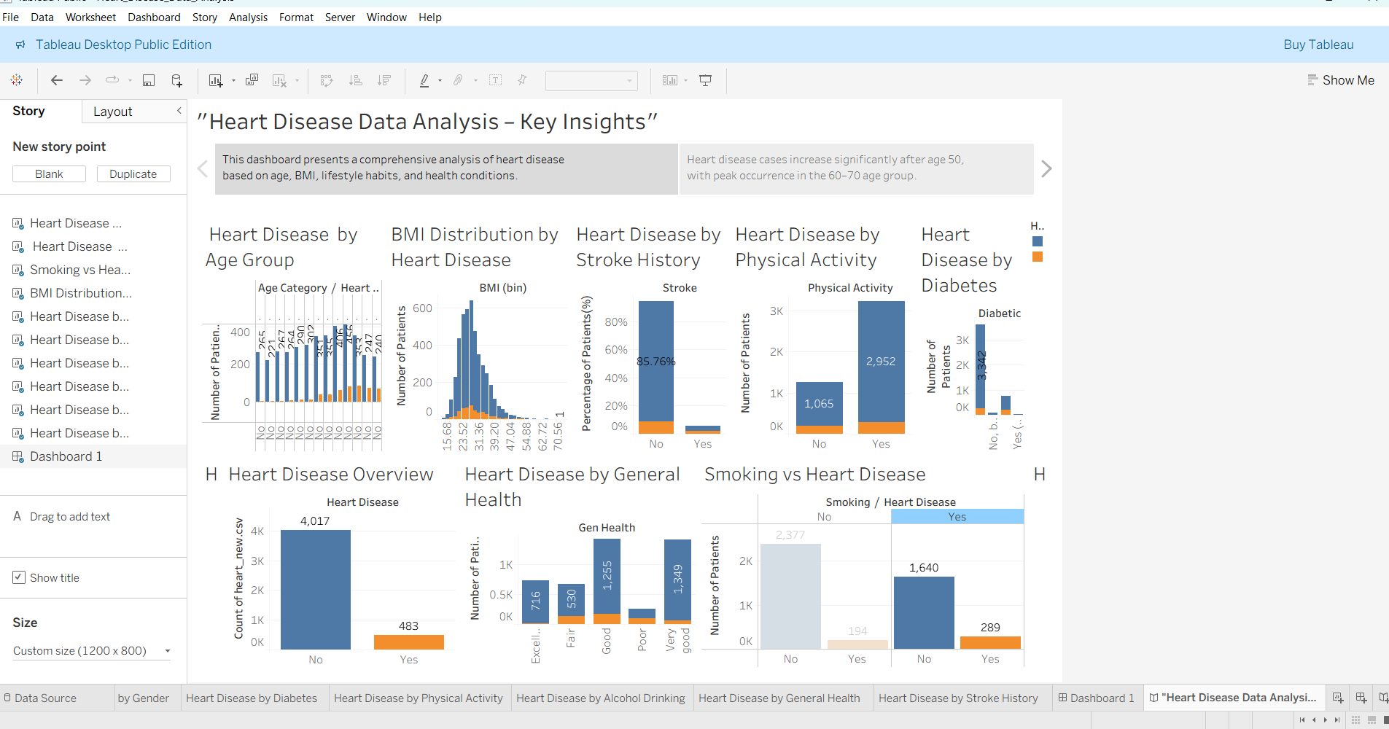
Web Integration
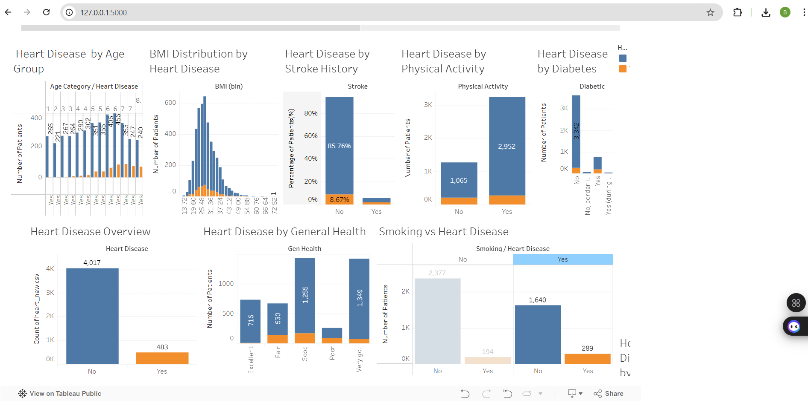
8. ADVANTAGES & DISADVANTAGES

Advantages
- Interactive Visualization
The dashboard provides interactive charts and filters that allow users to explore electricity consumption data dynamically.
- Improved Decision Making
Year-wise and region-wise analysis helps stakeholders make informed and data-driven decisions.
- Easy Trend Identification
Monthly and seasonal trends can be easily identified through line charts and comparative analysis.
- Time Saving
Instead of manually analyzing raw Excel data, the dashboard presents insights instantly.
- User-Friendly Interface
The system is simple to use and does not require advanced technical knowledge.
- Better Resource Planning
Helps energy planners identify high and low consumption regions for efficient energy distribution.
Disadvantages
• Dependent on Data Quality
If the input data contains errors or missing values, the analysis may not be accurate.
• Limited to Available Data
The dashboard can only analyze the data provided and cannot predict future consumption without advanced modeling.
• Requires Tableau Software
Users need access to Tableau to interact with the dashboard.
• Initial Setup Time
Data cleaning and dashboard development require initial time and effort.
9. CONCLUSION
This project analysed heart disease data using Tableau to identify key risk factors and trends. Interactive dashboards were created to study the impact of age, BMI, lifestyle habits, and medical conditions. The analysis revealed significant relationships between heart disease and factors such as diabetes, stroke, and physical inactivity. Data visualization helped transform raw healthcare data into meaningful insights. Overall, the project demonstrates the importance of data-driven decision-making in preventive healthcare.

10. FUTURE SCOPE
The project can be enhanced by integrating real-time healthcare datasets for continuous analysis. Machine learning models can be applied to predict heart disease risk more accurately. The dashboard can be deployed as a web application for wider accessibility. Advanced analytics such as trend forecasting can be incorporated. Additional health indicators can be included to improve risk assessment and decision support.
Dataset Link
https://drive.google.com/file/d/190Qmq27LeZZ_nWricP3Obl7ys_5otEsp/view
Project Demo Link
https://drive.google.com/file/d/11uqiasmZqot6PjdCWRex4QzDsuRnwkrA/view?usp=drive_link
Git hub Link
https://github.com/Bhavana137/heart-disease-tableau-analysis

